Hedges and Boosters — Homework Activities

1. Data Digging
Load the Professional Writing data set in AntConc.

Run a concordance for may. Sort the concordance by 1R/2R/3R. In the space below, write down at least five verbs that illustrate instances where may is used as a hedge.
Next, run a concordance for will. Sort the concordance by 1R/2R/3R. In the space below, write down at least five verbs that illustrate instances where will is used as a booster.
2. Writing Practice

Rewrite the sentences below by replacing the deleted material with hedges and boosters that are more appropriate for a technical or scientific text. You can place the new hedge or booster anywhere in the sentence.
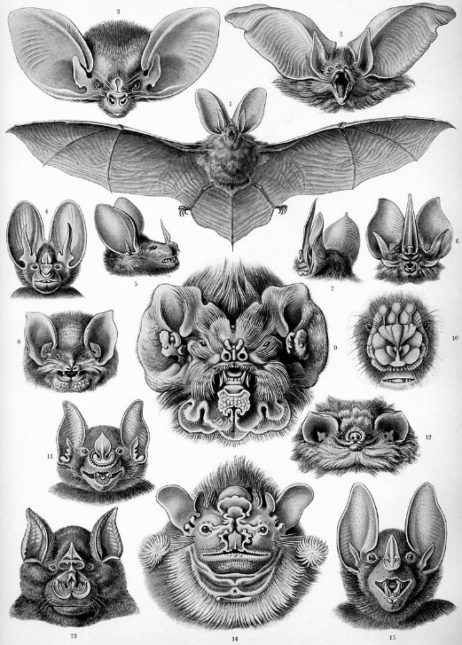
- Bats are pretty interesting animals.
Click or tap here to enter text.
- People believe that bats feed on blood, but actually the majority of bats are fruit-eaters.
Click or tap here to enter text.
- Bats are totally useful to humans in many ways: bat dung is used as fertilizer, and bats control pest populations.
Click or tap here to enter text.
- Bats can pose kind of a threat to humans because they are natural reservoirs of many pathogens such as rabies.
Click or tap here to enter text.

- Bats are often associated with darkness, malevolence, witchcraft, and death.
Click or tap here to enter text.
- The delicate skeletons of bats do not fossilize well: around 12% of bat genera that lived have a fossil record.
Click or tap here to enter text.
- Many bats can drop their body temperature to 43-86 °F and thereby reduce their energy expenditure for real.
Click or tap here to enter text.
- The University of North Texas hosts the largest artificial bat roost in the world, with 400,000 residents, give or take a few.
Click or tap here to enter text.
- In China, bats have sort of positive associations with happiness, joy, and good fortune.
Click or tap here to enter text.
- The largest bats have a wing span in the ballpark of 5.6 ft.
Click or tap here to enter text.

